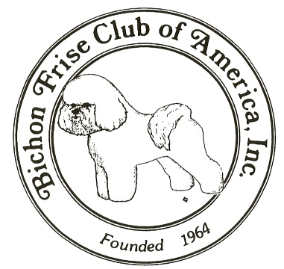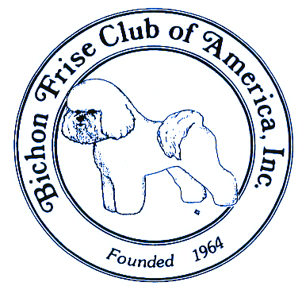

### **The Bichon Frise Club of America, Inc.**

### **National Specialty Issue**

SUMMER 2021

**Fall Issue Deadline October 20**

**(Publication November 1)**

**Inside this Issue**

**President’s Message** 3

**Annual Meeting Minutes** 6

**Officer Reports**

Recording Secretary Report 8

Board Ballots 9

Teller Report 8

Treasurer Report 11

**Committee Reports**

Delegate Report 12

Charitable Trust 13

Charitable Trust Financial 14

Judges Education 15

Membership 16

ROM/ROMX 17

**Local Club Reports**

BFC of San Diego 18

BFC of Northern California 19

**National Specialty 2021** 20

**Bulletin Editor:**

Mayno Blanding

3515 NW 221st Street

Ridgefield WA 98642

360-771-8978

MaynoB@gmail.com

**Officers**:

President, Myra Wotton

Vice President, Lillian Endo

Recording Secretary, Wendy Ball

Corresponding Secretary, Kayley Kovar

Treasurer, Matt Abbott

**Directors**:

Roz Allen

Gail Antetomaso

Paula Hendricks

Sheri Kennedy

Mary Spruiell

Shannon Tupes

**AKC Delegate:**

Mayno Blanding

**Enclosures:**

Membership Directory Update

Health Times

CHIC 5Star Report

The BFCA BULLETIN is the official newsletter of the Bichon Frise Club of America, Inc. and is published quarterly. Subscriptions by members of BFCA are paid as a portion of annual membership dues.

**President’s Message**

Summer is upon us and, thankfully, dog shows are coming back strong!

As I indicated in my July message sent via e-mail through a Constant Contact program, I have instituted monthly Zoom Board meetings. My goal, shortly after each Board meeting, is to communicate to you all in a timely fashion (via our e-mail Constant Contact program) the general business of BFCA that the Board discussed and, if appliable, the results of any votes taken.

I will continue to have a President’s Message in our quarterly Bulletin. However, the Board intends to utilize e-mails through the program Constant Contact much more than we have in the past. Therefore, **on August 6**, 2021, everyone will receive a **“TEST”** e-mail utilizing the Constant Contact program. If you receive this e-mail, then that’s *Terrific –* you’re all set! If you don’t receive it and have provided your current e-mail address to the Recording Secretary (as that’s where our list comes from) then please contact our Recording Secretary to make sure our records contain the up-to-date contact information for you. You should also e-mail Shannon Tupes who is responsible for sending out the Constant Contact e-mails to be sure Shannon also has the correct information in her distribution list. By doing this “Test” e-mail, I’m hopeful that we will have everyone successful in getting the Constant Contact e-mails so that everyone has access to the same information.

The top of the e-mail will look like this:

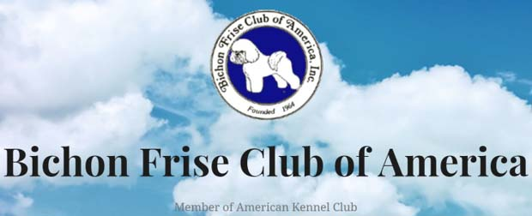

Here’s a Summary of my July e-mail message:

1. BFCA All-Breed Agility Trials needs a person(s) to take over this Show Chair; otherwise, BFCA will no longer have these fun trials. Anyone interested need only to contact any Board member of his/her interest.
2. Laura Winston (due to personal reasons) has stepped down as Health Chairperson. Nancy McDonald will temporarily resume this position.
3. Any future surveys will be handled through Formidable - a program that we also use for our new website.
4. AKC is conducting Meet the Breeds at various locations throughout the USA this year. AKC is charging any Parent Club participating at any location $500 for a booth. Any local club interested in Meet the Breeds should contact any Board member and the Board will discuss it.
5. The Bichon pictures on our new website have been changed. We have a new picture on our Home page as well as new pictures scrolling at the bottom. As a reminder, one of the goals of our updated website is to be more welcoming to the public and, hopefully, entice interest (membership) in our Club as well as show our beloved Bichons as the fun-loving, family-friendly breed that they are.

We need non-show pictures of our beloved Bichons to continue the periodic swapping out of website pictures. Please continue to e-mail your pictures to Gail Antetomaso at [gailofgaylor@gmail.com](mailto:gailofgaylor@gmail.com).

If you have not yet had the opportunity to explore BFCA’s new website, I encourage you to do so. Our new website has a wealth of information on various aspects of our Club, and our Health Committee is now a part of our new website (instead of their own website). All of our active local clubs are listed on the website along with the contact person for each local club. Under the Events tab, you will find an Events calendar – please send to me the dates of any event, along with any print-ready information, you would like to share with the membership. Also, under the Membership tab, you will find many items including our Membership Only section where our current Membership Directory can be found. Until we are able to have individual passwords, the password for everyone is: accessbfca20 (all lower case).

The Board is extremely close to finalizing the updated Constitution and Bylaws and will forward the final revised version to the membership for a vote soon. Once the membership votes and, if approved, the revised Constitution and Bylaws will be sent to AKC for their approval. The revised version will NOT be final until after we receive AKC’s approval. At that time, I will notify the membership.

The Board and Cyndie Adams, Show Chair, continue to work on the National Specialty and Parent Club Specialty in Madison, WI, in November.

Thanks to everyone who voted on the trophies for our National. As a result of your vote, the combination of hand-painted Bichon items and the engraved scissors/comb will be offered. A committee consisting of Kayley Kovar, Lillian Endo, and Matt Abbott will recommend to the Board which award placement will receive which trophy.



Our Chair for the ROM/ROMX & Top Ten committee, Lindsay Van Keuren, has resigned. The Board thanks Lindsay for her service on this committee. Roz Allen has graciously accepted the position of Chair of this committee and will work with Lindsay to facilitate a smooth transition. Thanks, Roz!

BFCA will be providing medallions for our Bichons through AKC at the AKC National Championship in Orlando in December for Conformation as well as for Performance events.

As most of you are aware, BFCA’s Facebook page was done by Lynn Ramich. For personal reasons, Lynn has resigned from keeping up our Facebook page. Thanks, Lynn, for your many years of dedication to our Facebook page. Shannon Tupes, who currently sends out the e-mail correspondence through Constant Contact, has taken over responsibility for our Facebook page. Also, Shannon, with the assistance of Amanda Aaron, has created a BFCA page on Instagram and will be responsible for this page as well. Thanks, Shannon and Amanda!! So, please check out our new pages – we hope you like the new ideas Shannon and Amanda will be posting! Please feel free to reach out to Shannon and/or Amanda with any ideas or contributions for our social media pages.

I would like to announce that the new trustees for the BFCA Charitable Trust (Rescue) are Gail Antetomaso, Lynn Ramich, Zandra Kern, Michelle Lapp, and myself.

I would like to conclude this message by again thanking everyone for electing me your President. I and the new Board will be working hard for all of our members over the next 2 years.

I hope the summer blesses you all with many ribbons!

I look forward to seeing everyone in Madison, WI, in November at our National & Parent Club Specialties!!

**Remember to watch for your TEST Constant Contact e-mail on August 6, 2021!!**

Myra Wotton

**Annual Meeting Minutes**

Meeting began at 7:12 PM

Deb Gibson taking names

Approved minutes from 202 with no corrections

Treasure’s report – No Questions

Rescue Lynn – No Questions

Heath committee welcomed Laura Winston as chair

Judges Education – Having one at National and one in Houston and one in Oregon. Ms. Winkler said she needed help.

Judy Beckham – Said 2 Specialties on the 18th & 20th. “And it’s going to be a surprise”

Ms. Winkler wanted to know when she can do Judges Ed at National. Matt said During the All-Breed Shows.

Gail talked about the new website and explained it was still a work in progress. She also talked about the ongoing By Laws update and the proposed new Associate Membership. It has gone to AKC and will passed onto the new Board.

Gail said Sheri has done a great job on membership. She thanked Lynn and John for being on the Board.

Election Results were announced.

Submitted by,

Debbie Hollan

BFCA Corresponding Sec.

* * * * * * * * * * * * * * * * * * * * * * * * * * *

After the election results were announced. Vice President Elect, Lillian Endo, thanked the membership for attending the annual meeting, voting in the election, and above all for their support of the Bichon Frise Club of America. Lillian reminded the attendees of our upcoming National Specialties and the Greater Houston Bichon Club Specialties to be held in Madison Wisconsin November 17th - 20th 2021. She stressed that we need volunteers to make the 2021 Nationals a special event. The BFCA is asking you to join us, get involved, and have fun! The Nationals will be doing a fundraiser raffle, please help us by donating.

Remember, it takes all of us to make this club successful! See you in Wisconsin!

Kayley Kovar

Corresponding Secretary

**2021 BFCA ANNUAL MEETING**

**ATTENDEES LIST**

**MAY 25, 2021**

**Matt Abbott Sheri Kennedy**

**Paula Abbott Kayley Kovar**

**Cynthia Adams Kathleen Loynachan**

**Roz Allen Larry Letsche, DVM**

**Ben Anderson Merry Nicole Meyer**

**Kathy Andrew Andrew (Gene) Mills**

**Gail Antetomaso Mary Ellen Mills**

**Elaine Arrastia Nancy Muklewicz**

**Camille Bakker Richard Newton**

**Danell Bartsch Nancy Noonan**

**Judy Beckham Karen A. Paulson**

**Paula Bender Neena Pellegrini**

**Mayno Blanding Van Rametta**

**Susan Brockett Linda Rowe, PhD**

**Gary Brown Lynn Ramich**

**Nancy Brown Joanne Rubin**

**Ashley Burks Harvey Sarner**

**Javier Car Karen Snyder**

**Ruth Car Mary Spruiell**

**Lorrie Carlton Sue Swindle**

**Donna DeMartini Dina Taylor**

**Lindsey Dicken Shannon Tupes**

**Cheri Ekholm Lindsay Van Kueren**

**Lillian Endo Kathie Vogel**

**Carol Fellbaum Jan Wilson**

**Paul Flores Mimi Winkler**

**Tamara Fossier Laura Winston**

**Linda Freidline John Wise**

**Kim Furlong Leanne Wise**

**Debra Gibb Laureen G. Zelek**

**Karen Graeber **Also reported on call\*\***

**Nita Gryan Nancy (No Last Name)**

**Anna Hillman Lenovo User’s IPhone TKC**

**Debbie Hollan Danielle Ardagna**

**Tasheena Housman**

**Donna Jones**

**This showing 69 Members present on the call.**



**Recording Secretary Report**

Hi All….Hope this finds all our members well and excited about getting back in the show ring. Things are busy here with a litter getting ready to leave and BFCA business to do - it’s a full-time job.

Our wonderful BFCA Board is helping to notify those members who have not paid their dues as of yesterday (July 14, 2021).

A word to the wise…PLEASE DON’T UNSUBSCRIBE TO OUR CONSTANT CONTACT! Director Shannon Tupes has been doing a wonderful job with the Constant Contact and now, with the help of Amanda Aaron, will be doing a lot on social media. We use the Constant Contact to notify BFCA Members of various events and issues coming up.

If you have any changes to your information, be sure and include that when you pay your 2021-2022 dues.

Please remember to keep us informed, so we can keep you informed.

Bichon Kisses,

Wendy Ball

BFCA Recording Sec.

**Board Ballots**

**Ballot: 05-21A To Suspend Bylaws reference Notification and Date of BFCA Annual Membership Zoom Meeting**

**Motion: To further suspend the Bylaws in respect to meeting notification and rescheduling the Bichon Frise Club of America’s Annual Membership Zoom Meeting to Tuesday, May 25, 2021 at 7PM EDT, 3PM PT.  A Constant Contact will be sent reference this for notification to membership later this week.**

**Passed unanimously, no response from Lynn Ramich.**

* * * * * * * * * * * * * * *

**Ballot: 06-21A 2 Part Ballot ref: Website Contract and Retaining Webmaster**

**Motion 1: BFCA Board will continue with the webmaster contract with Wes Brown of Brown House Media Group for enhancement and maintenance of BFCA website, and pay the costs as outlined in the contract previously signed by Pres. Gail Antetomaso on September 16, 2020.**

**Motion 2: Wes Brown of Brown House Media Group will be the BFCA’s webmaster until such time that the BFCA Board votes to terminate Mr. Brown as our webmaster.**

**The 2-part ballot, passed unanimously on both parts.**

**Teller Report**



**Treasurer Report**

Our treasurer was not able to get the report to the editor in time for publication.

It will be included next time.





**Delegate Report**

**Mayno Blanding**

The June meeting of AKC Delegates took place by Zoom June 2-8, 2021. I attended all meetings except the performance and companion dog meetings. Items of primary interest to BFCA members are from the **Parent Club Committee.**

Most clubs have ***preferred seating*** that is offered for sale or by bidding as a fund raiser. They would like us to set aside one or more spaces to donate to ***AKC government relations****.* I have the details if we want to do something like this.

I am happy to report that the BFCA Health Committee has sent in their ***health statement*** to AKC.

There is a ***Juniors***subcommittee working on a program for Parent Clubs (PC’s) to encourage Jr. participation in our breeds. They recommend that clubs add a ***junior coordinator*** if they are interested in this. Many clubs already have this person and are doing great things with their programs. Coordinators are helping juniors with ownership, teaching them anatomy and the breed standards, and they are also matching juniors with mentors.

***Pupdate*** – A series of emails goes out to new owners and is breed-specific. Nineteen PC’s have signed up to do this. I don’t know if BFCA has signed up yet but they want all PC’s on board. They want to encourage all new owners to get involved in their PC or local club.

Another subcommittee of interest is the ***Best Practices*** subcommittee. They are pretending they are a brand-new PC and are just setting up their club from scratch. They have identified 10 elements, including staging a national specialty, membership, elections, etc., which will go into an online reference for clubs.

There is also an ***Archives*** subcommittee that will help PC’s struggling with what to do with all the “stuff” they have accumulated through the years. They are working with the AKC Museum of the Dog. I have contact information if we are interested.

I already shared with the Board an article on the ***AKC Purebred Preservation* *Bank***. This is a semen bank to keep breeds from going extinct and to keep healthy dogs from being lost forever. AKC will not profit from the semen bank – it is a 501c3. If we don’t participate, AKC will do Bichons without our support, so we probably should get involved. This would be a perfect project for the BFCA Health Committee as we have already expressed interest on the subject. The AKC has very good arguments to support this endeavor.

Many of you may be aware of the proposal for ***Bred-by-Exhibitor Puppy Classes***. It has been very well received by the delegates. More on this to come in the next Bulletin.

**Delegate General Meeting:** ***Forum on Nutrition:*** This was outstanding, and I am hoping that we will be sharing this presentation with members. AKC gave their usual sunny report of what they are accomplishing in a lovely ***video*** which may be shared with all BFCA members. The recipients of the *AKC* ***Lifetime Achievement Awards*** were announced and have been shared with the BFCA Board.

These are only a few highlights from the June Meeting. If anyone has questions, please contact me.

Mayno Blanding

Delegate, BFCA

maynob@gmail.com

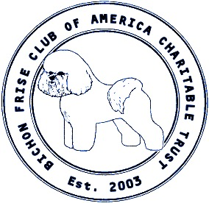

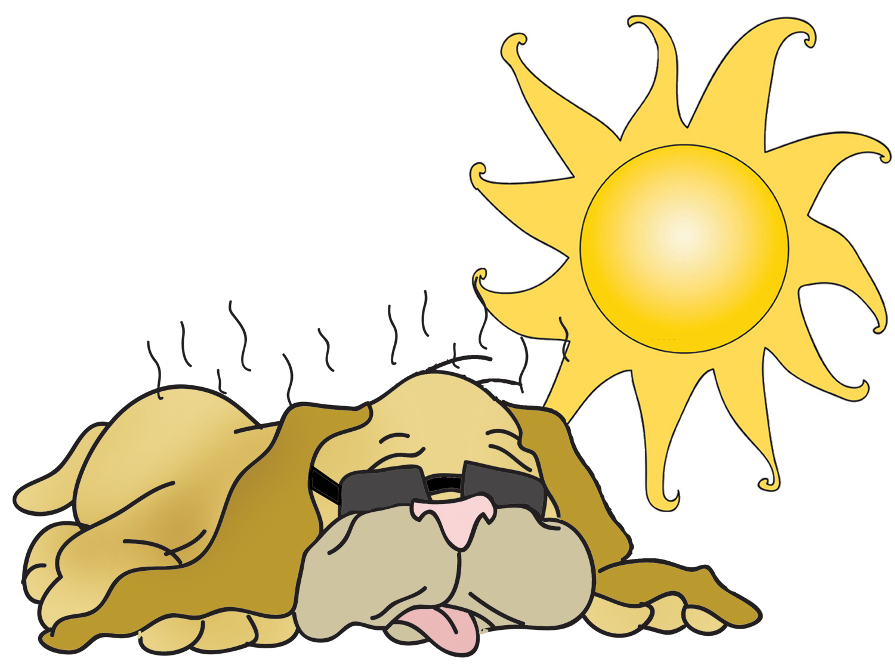

**Summer 2021**

Hope everyone is well and happy to be free from this pandemic. During the pandemic, very few dogs came into rescue. We ended up taking some permanent fosters, at the time, we didn’t know they had severe health issues. Right now, we have seven permanent fosters. Funny thing, five are in Florida!

Things seem to be picking up. We had seven turn in requests in June. That is more than we had in any month since the pandemic. We shall see how things go as more states open up.

We are still selling out nightshirts. Feedback has been very positive. They are soft and comfortable and true to size. Remember the proceeds of the shirts go to the care of our rescues.

<https://bichon-frise-club-of-america-charitable-trust.square.site/product/bichon-night-night-shirt/2>

Lynn Ramich

Co-Chair and Trustee

Bichon Frise Club of America Charitable Trust

**BICHON FRISE CLUB OF AMERICA**

**CHARITABLE TRUST**

**Est. 2003**

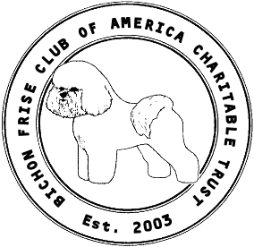

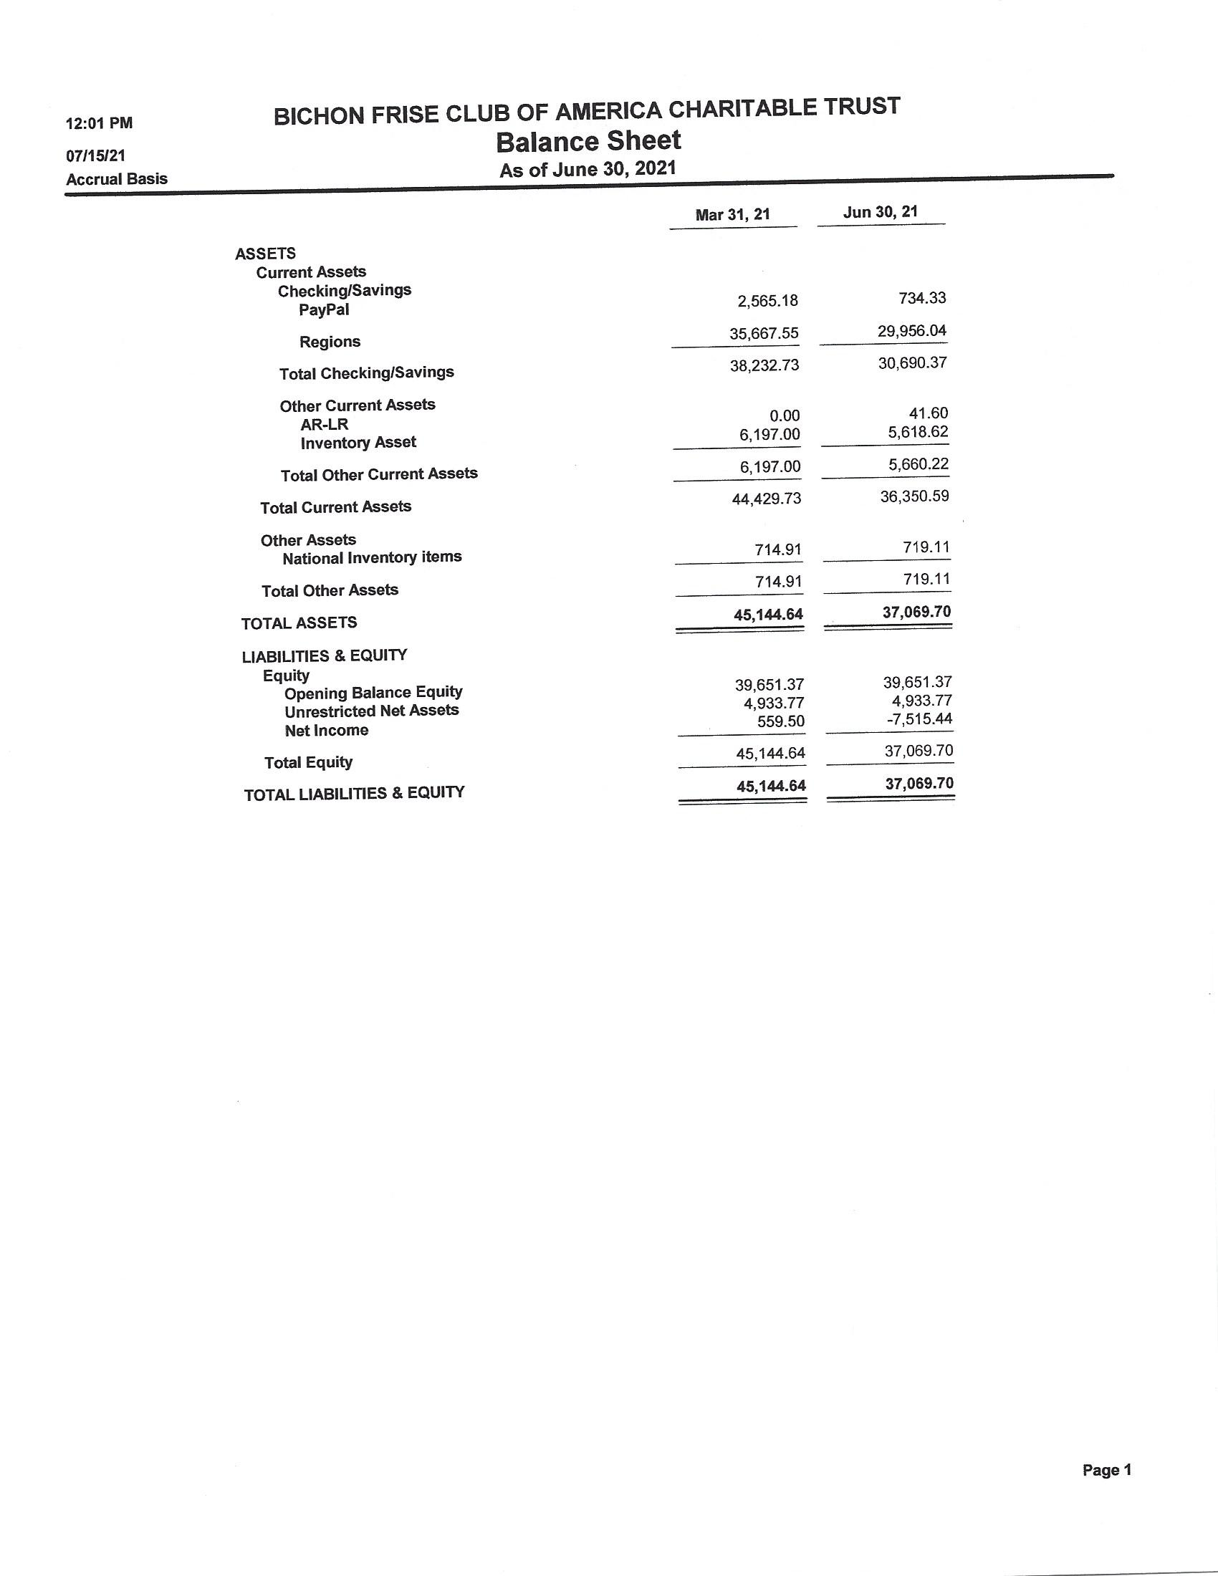

**BICHON FRISE CLUB OF AMERICA CHARITABLE TRUST FINANCIAL REPORT**

**Est. 2003**



**Judges Education Report**

I am so pleased that shows are going back to normal and we can get to socialize our dogs and be with our friends…Telephone, and zoom lessons are beneficial….but in person is the best…

On July 21, 2021, I leave for Houston to present my first seminar for Judges Education in well over a year..I am so pleased that members have volunteered their dogs and time to do hands on with me. i would like to thank them in advance for offering.

In November, at our National, I will again be giving a Judges Education seminar on Wed. followed by Sweeps, Lunch, Conformation and Hands On We will be doing ringside mentoring Thurs. Friday, Saturday and Sunday …I would appreciate members volunteering to help as it is beneficial for judges to hear from different people…

I would also like to see if we can arrange a little time for all AKC approved ringside mentors to get together…I want us all to be on the same page and never tout our own dogs…We may all have preferences, but it is the standard we must be sharing and teaching.

I hope you all have a healthy, happy summer

Mimi Winkler

Judges Education Coordinator BFCA

AKC Delegate Saw Mill River K.C. DAAC Committee Member

AKC Judge #65274



**Membership Report**

***Summer 2021***

***Sheri Kennedy***

**NEW MEMBERS (Sponsors)**

Kathy Martin

4763 Shepherd Street

Burnaby, BC V5H 1L6

Canada

(Sue Swindle & Sheri Kennedy)

**NEW MEMBER APPLICATIONS (Sponsors)**

*All BFCA members are invited to send comments (both pro & con) regarding applicants. Comments must be received by the Recording Secretary, Wendy Ball, 967A Boat Dock Rd, Somerset, KY 42501 or bichonbabe@mchsi.com by August 15, 2021*

Lewis Waldeisen

77905 Cottonwood Cv.

Indian Wells, CA 92210

(Lorrie Carlton & Roz Allen

Sari Bankson

4333 24th Avenue, Lot 114

Fort Gratiot, MI 48059

(Terrell Potts & Anna Hillman)

Angela Lewis

38820 Ypupon Trail

Eustis, FL 32736

(Rick Day & Sheila Feldman)

**ROM/ROMX Report**

**Congratulations to the following Register of Merit Recipients:**

CH LUXURY LOVE SINTIYA TKN

Bred by Irina Smirnova

Owned by *Amanda Aaron

CH KAMIANS PARALYZER

Bred by Ana Vladimirov and Tatjana Simic

Owned by *Lorrie Carlton and *Larry Letsche, DVM

*Denotes BFCA Member

All ROM/ROMX submissions should be submitted to:

Lindsay Van Keuren

5323 Sage Thrasher Rd

Parker CO 80134

[Aspenvista1@gmail.com](mailto:Aspenvista1@gmail.com)

As a reminder, your applications should be submitted with the current AKC Registration of the Dog and an AKC Progeny Report. In lieu of a Progeny Report, you may send the pages of the Bichon Frise Reporter, announcing the Championships of the Dam or Sire’s get.

Qualifications for ROM/ROMX:

It is the responsibility of the Owner of a proposed dog to submit the required information to the ROM/ROMX Chairperson for confirmation. The Owner must be a BFCA member in good standing.

To be eligible for a Register of Merit Excellent (ROM) title, the subject dog is to have been the sire of seven (7) or more Champions of Record or the dam of five (5) or more Champions of Record. To be eligible for a Register of Merit Excellent (ROMX) title, the subject dog is to have been the sire of twenty-five (25) or more Champions of Record or the dam ten (10) or more Champions of Record.

**Bichon Frise Club of San Diego**

The Designated Specialties of the Bichon Frise Club of San Diego were hot, hot, HOT! We had a sudden heatwave but we all soldiered on and had a wonderful three days of showing our bichons.

On Friday, we had Michelle Shultz as our Sweepstakes judge. She is a charming lady with a great eye for dogs. Here is her evaluation. On Saturday, Lynn Wyza was our Sweepstakes judge. Another lady who fit right in with our exhibitors, has a great deal of experience with dogs, and did a great job evaluating our entries. Sunday’s Sweeps judge was Jan Hill, another experienced local breeder/owner/handler with a strong history with several breeds. She had nice things to say about our Sweeps entries. All of our Sweeps judges’ critiques will be in our article I the Fall issue of the Bichon Frise Reporter and hopefully posted on our website.

After each day’s show, we all retired to the set-ups area and celebrated the life of well known and respected breeder/handler Joe Waterman who passed away last year and to whom we had dedicated this year’s shows. As most of you know, Joe was an important part of our breed’s development. A special friend of Joe and Dorinne flew here from Hawaii with custom bouquets for the occasion. They were so beautiful!

Our website has links to more photos, placements each day, and information for our 2022 Specialties. After this year’s success, we plan a “threepeat” with Silver Bay Kennel Club in February. Watch the website and our Facebook page for news and updates. <http://bichonfriseclubofsandiego.com/2021specialty/>

In closing, I’d like to add that two of our Sweeps judges were open to mentoring and Ms. Shultz completed her paperwork to apply for judging bichons.

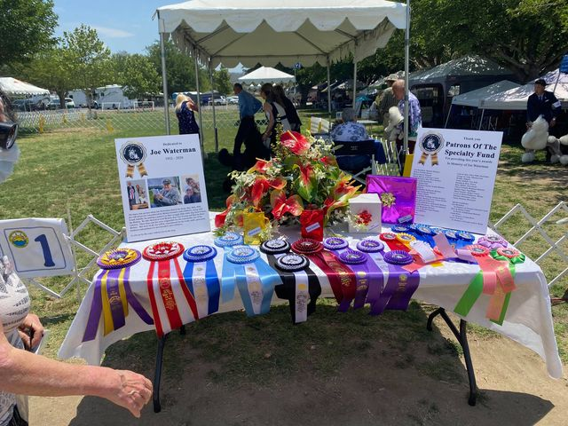

**Bichon Frise Club of Northern California**



Greetings from hot and toasty California!

So pleased to announce that Donna Di Martini and her committee were able to schedule our designated specialties with the Sacramento Valley Dog Fanciers for October 30th & 31st in Dixon, CA. As was reported last time the specialties will be held at the Dixon-May Fairgrounds which has ample overnight parking on grass, plenty of local restaurants, and hotels. For those wishing to make a vacation out it you can easily tour the Wine Country in Napa, take a day and go to San Francisco, or even travel to the Sierras; all within a few hours of Dixon. For further information please contact Donna Di Martini directly. The premium list will be posted with MB-F.

Plans are being discussed to have our annual Christmas party and I know many of us are looking forward to revenge at the “steal a gift” exchange!

A few of our members are back out hitting the dog show circuits now that we have some shows again in California and on the West Coast in general.

Congratulations to Becky Buckman and Bill Tongren on their newest champion, Jasper! Jennifer and Tom Eikmier recently traveled to Idaho and picked up a few majors on one of their girls as well.

From our membership to yours please continue to be safe everyone and look forward to seeing you all in October at our specialties and that of the BFCA National.

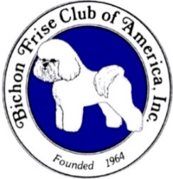

**45th Bichon Frise National Specialty**

**and Concurrent Specialty**

**Alliant Energy Center, Madison WI**

I hope that everyone is making plans to attend the 45th National Specialty on November 17, 2021 and the Parent Club Specialty on November 19, 2021. In addition, the Houston Club will be holding a specialty November 18th and there will be 4 days of all-breed shows. Four days of wins and fun! If you haven’t made your reservations yet, I encourage you to do so soon. Information on the hotels available is listed on the Renaissance Cluster web site at: [www.renaissancecluster.org](http://www.renaissancecluster.org) Designated grooming space for our Bichons is available at $25.00 for all four days, and reservations for the grooming space can be made on the cluster web site. I’ve been told that the grooming space is only about 15 feet from where the Bichon ring will be. Bathing of the dogs in the hotel rooms is prohibited, but the cluster will have bathing stations set up at the Alliant Center starting at 6AM on November 17th. Access to the Alliant Center is not available until 6AM on the 17th. We are looking to have a small hospitality night on Wednesday evening. Catalog ads should be sent to Roz Allen and there will be more information coming regarding price of the ads and the deadline. According to National Weather information, the average temperature in Wisconsin in November is 46 degrees, and usually no snowfall. If anyone has questions please feel free to contact me or Myra Wotton.

We’re looking forward to seeing many of our friends and lots of beautiful dogs!

Cyndie Adams

2021 Show Chair