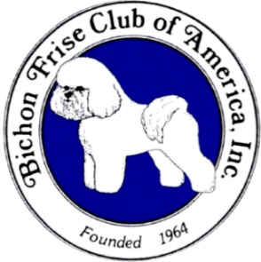 BICHON FRISE CLUB OF AMERICA
Futurity Litter Nomination Form
Please Print Clearly:Use this form from November 2 2023 to Nov 8, 2024.
Futurity Show Year: 2025 Judge: Paul Flores Show Location: University Plaza Hotel & Convention Center 333 S John Q Hammons Parkway, Springfield MO Show Date: May 8, 2025
Registered Name of Dam _______________________________________________________
Dam AKC Reg # ______________________________________________________________
Registered Name of Sire ________________________________________________________
Sire AKC Reg # ______________________________________________________________
Date of Breeding(s) ______________________ Estimated Whelping Date ______________
Breeder(s) ___________________________________________________________________
Address/Contact Info of Breeder submitting this Nomination:
Street ______________________________________________________________________
City _______________________________________________________________________
State _______________ Zip ____________ Country _________________
Phone (___) _______________ E-mail _______________________________________
Fee: $25.00 This Litter Nomination Form must be accompanied with a check payable to BFCA. All foreign exhibitors must pay with checks drawn on U.S. accounts or with International money orders in U.S. funds. Please include the Dam’s AKC Reg Name on your check/money order.
PLEASE DO NOT SEND CASH! Do not send by Certified Mail or Air Express.
Submit health testing certificates for Sire & Dam (as described in Rules) with this form.
Send this Nomination Form along with your check/money order to:
Donna deMartini 9180 Los Lagos Circle S Granite Bay, CA 95746
Phone: 916 847-0151 Email: demartinidonna991@gmail.com
Eligibility is determined by the postmark date, not delivery date (except for the Futurity closing date prior to judging).

